|  |  |
| --- | --- |
| MONDAY  4/11/16 | **CUMALATIVE TEST** |
| TUESDAY  4/12/16 | **What is a wave?** A transfer of energy |
| WEDNESDAY  4/13/16 | **What type of wave does Not require a medium?** Electromagnetic |
| THURSDAY  4/14/16 | **Explain the following – Reflection, Refraction and Diffraction.**  Reflection – bounce back  Refraction – Bending  Diffraction – spreading out |
| FRIDAY  4/15/16 |  |

**Properties of Waves**

**Wave:** **A transfer of energy in the form of a disturbance**.

It can be in a **Medium** or a **Vacuum – outer space – no air**.

**Types of waves:**

1. **ELECTROMAGNETIC**

* Examples -- light waves, radio waves, microwaves, X-rays, etc.
* Do **NOT** require a medium for transfer; can be transferred through a vacuum.

1. **MECHANICAL**

* Examples -- sound waves, water waves, etc.
* Require **A MEDIUM** for transfer; cannot be transferred through a vacuum.

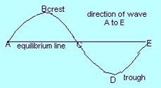**Types of mechanical waves:**

1. **TRANSVERSE**

As a wave passes through a point, the particles vibrate at **RIGHT** **ANGLES**  to the direction in which the wave is moving

* **CREST** - upward displacement of transverse wave
* **TROUGH** - downward displacement of transverse wave

1. **LONGITUDINAL - SOUND**

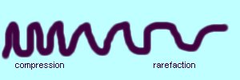As wave passes through a point, the particles vibrate **PARALLEL** to the direction in which the wave is moving

* **COMPRESSION** – close together
* **RAREFRACTION** – further apart

**Wave terms:**

|  |  |
| --- | --- |
| **WAVE LENGTH** | the distance between two successive in-phase points; symbol is \_\_λ\_\_ |
| **AMPLITUDE** | maximum displacement of wave; measure of wave's energy |
| **PULSE** | a single disturbance of a medium |
| **FREQUENCY** | the number of waves passing a point per second; symbol is *f* and SI unit is Hertz (\_Hz\_\_\_) |
| **PERIOD** | time for one wave; symbol is *T* and SI unit is second |

**f = 1/T**

**T = 1/f**

* **Speed** -the speed with which the wave moves through the medium is the product of the wavelength and the frequency; SI unit is m/s

V = fλ

The wave equation

**Samples:**

* 1. The Sear’s building in Chicago sways back and forth at a frequency of about 0.1 Hz. What is the period of vibration?

T =1/f T = 1/.1 = 10 sec

* 1. If a water wave vibrates up and down two times each second and the distance between wave crests is 1.5 m, what is the frequency of the wave? What is the wavelength? What is its speed?

3. What is the wavelength of a 340 Hz sound wave when the speed of sound in air is 340 m/s?

V =fλ 340 = 340λ 340/340 = λ 1 m = λ

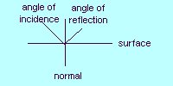**Wave properties**:

1. **REFLECTION** - "bouncing back" of a wave
2. Laws of Reflection - The angle of **INCIDENCE** equals the angle of **REFLECTION** (or it can be stated θ1 = θ2) ; the incident wave, the reflected wave, and the normal all lie in the **SAME PLANE**
3. Angle of incidence and angle of reflection are always drawn relative to the normal

**Normal**  - line drawn **PERPENDICULAR** to surface

1. Example of reflection - echo
2. **Refraction** - "**BENDING** of waves"
3. 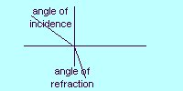A wave passing from one medium to another medium of different density changes its **SPEED** causing it to **BEND**
4. The speed of the wave is greatest in the less dense medium if it is a **LIGHT** wave. **SOUND** waves travel faster in **DENSE** mediums.
5. **Interference** - result of the superposition of two or more waves
6. **Superposition Principle** - when two waves are in the same place at the same time, the displacement caused by the waves is the algebraic *sum* of the two waves
7. **CONSTRUCTIVE interference**
8. Waves interfere, "adding" to produce a **LARGER** wave
9. Trace the line that represents the sum of the two waves.

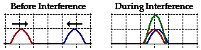

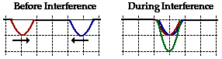

1. **DESTRUCTIVE interference**
2. Waves interfere, "adding" to produce a **SMALLER** wave
3. Trace the line that represents the sum of the two waves.

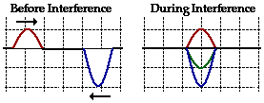

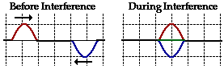

1. 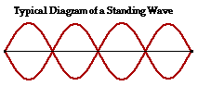**Standing wave** - two waves with the same **WAVELENGTH**, the same **FREQUENCY**, and the same **AMPLITUDE** that are traveling through a medium in opposite directions interfere producing a standing wave
2. **NODE** - point of zero displacement on a standing wave
3. **ANTINODE**- point of maximum displacement on a standing wave
4. **DIFFRACTION**- spreading of waves around a barrier

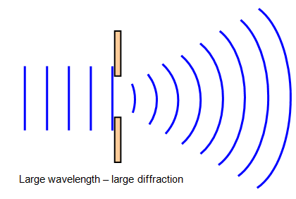

5. Waves at boundaries between different media:

1. speed of wave doesn't depend upon frequency or amplitude of wave; speed depends upon the properties of the **MEDIUM**
2. at a boundary, part of the incident wave is **REFELCTED** back upon itself in the original medium and part is **TRANSMITTED** through the second medium
3. the more **DENSE** the second medium is, the **LESS** wave energy is transmitted
4. the reflected wave, the incident wave, and the transmitted wave all have the same **FREQUENCY**; the velocity and the wavelength of the waves change
5. when a wave passes from a less dense to a more dense medium, the reflected wave is **INVERTED**
6. when a wave passes from a more dense to a less medium, the reflected wave is **UNCHANGED**

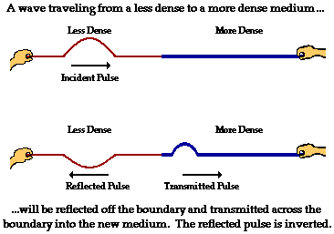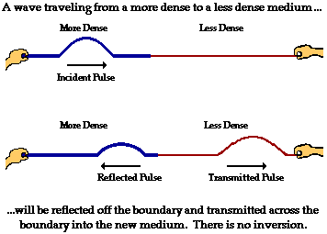

6. **Reflections**

* a free end reflection reflects the **SAME**
* a fixed end reflection reflects **INVERTED**

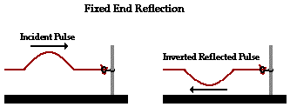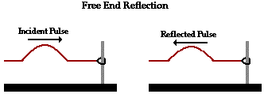

|  |  |
| --- | --- |
| MONDAY  4/18/16 |  |
| TUESDAY  4/19/16 | A pulse travels from a spring to a thin thread of rope that is attached to a wall. Describe the pulse in the THREAD after it leaves the spring at point “A” |
| WEDNESDAY  4/20/16 | **Does the frequency of the sound wave change on an ambulance siren?** No it just appears to change as it moves towards or away from you |
| THURSDAY  4/21/16 | **An ambulance that is moving at 25 m/s is blowing its horn at 800 Hz on its way towards a house on fire. The homeowner is standing on the curb?**   1. **What frequency does the homeowner hear?**   F = f ( $\frac{V}{V}$ $\frac{±}{±} \frac{V d}{V s}$)  F = 800 ( $\frac{345}{345}$ $\frac{±}{±}$ $\frac{0}{25}$) = 862.5 HZ |
| FRIDAY  4/22/16 | QUIZ |

Chapter 13: Sound

**Characteristics of sound:**

* All sounds are produced by the **VIBRATIONS** of material objects.
* Sound is a **MECHANICAL** wave.
* The speed of the sound wave is dependent upon the **MEDIUM** in which it travels. The speed is generally greater through **DENSER** materials.
* Speed of sound is **TEMPERATURE** dependent

At 0˚C, speed of sound is 331.5 m/s

**vair = 331.5 + (0.6) (TEMP)**

Note: if the speed of sound or temperature is not given, assume it is **345** m/s.

* Sound exhibits wave properties - it reflects producing an echo; it interferes constructively and destructively; it **REFRACTS** or bends; it **DIFFARCTS**, or spreads around barriers
* Sound waves propagate in **THREE** dimensions.

**Sample:** What is the speed of sound when the temperature is 30.0˚C?

**Vair = 331.5 + (0.6)(30) = 349.5 m/s**

**MACH #** - How fast an object is traveling, expressed as a multiple of the **SPEED OF SOUND**. A plane traveling at Mach 2 would be traveling at **TWICE** the speed of sound.

**Sample:** What velocity of sound in air would correspond to Mach 1.8?

**(1.8)(345) = 621 m/s**

**VIDEO ON SOUND**

**Terms:**

* **Speed:** the speed of a wave is given by v = vlg_2zum[1] f
* **PITCH :** frequency
* **LOUDNESS :** amplitude
* **DECIBLES :** unit for measuring sound level
* **TIMBRE :** sound quality
* **BEAT :** what a listener hears when 2 sound waves of slightly different frequency are played
* **RESONANCE :** a vibrating object induces a vibration of the same frequency in another object
* **NATURAL FREQUENCY :** the particular frequency that an object tends to vibrate (or resonate) at when disturbed

**Intensity level ( β )** The units of the intensity level of sound are decibel, or dB, in honor of Alexander Graham Bell. Since the intensity level is based on a log scale, every change of 10 dB means that the sound is **10** times more intense; a change of 20 dB means that the sound is 102, or 100 times more intense.

**Sample:** Meredith measures the sound intensity level in the classroom at 60 dB and at 120 dB at a rock concert. How much more intense was the sound at the rock concert than in the classroom?

60 dB to 120 dB is a change of 60 dB. 10 x 10 x 10 x 10 x 10 x 10 = 1,000,000

**The Doppler Effect**

**Doppler shift** - change in **FREQUENCY** of waves received by an observer whenever the wave source and/or the observer are in motion toward or away from one another.

v = speed of sound

vd = speed of detector vs = speed of source

vd = 0 if detector is stationary vs = 0 if source is stationary

vd is positive if detector is moving vs is negative if it is moving

toward source toward the detector

vd is negative if detector is moving vs is positive if it is moving away away from the source from the detector

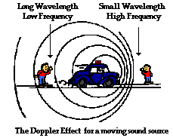

Hint: when working Doppler shift problems, associate the word **toward** with a frequency **INCREASE** and the words **away from** or **recede** with a frequency **DECREASE\_**.

**Sample:** A train moving at a speed of 40.0 m/s sounds its whistle, which has a frequency of 500 Hz. Determine the frequency heard by a stationary observer as the train approaches the observer. The ambient temperature is 24.0˚C.

331.5 + (0.6)(24) = 346 m/s

F = f ( $\frac{V}{V}$ $\frac{±}{±} \frac{V d}{V s}$)

F = 500 ( $\frac{346}{346}$ $\frac{±}{±}$ $\frac{0}{40}$)

F = 500 (346 / 306) = 565.35 HZ

**Sample:** Use a speed of sound of 345 m/s. An ambulance travels East on a highway at a speed of 33.5 m/s, its siren emitting sound at a frequency of 400. Hz. What frequency is heard by a passenger in a car traveling West on the same highway at 24.6 m/s if the car and ambulance are

* approaching each other?

F = f ( $\frac{V}{V}$ $\frac{±}{±} \frac{V d}{V s}$)

F = 400 ( $\frac{345}{345}$ $\frac{±}{±}$ $\frac{24.6}{33.5}$)

F = 400 (369.6 / 311.5) = 474.6 HZ

* moving away from each other?

F = f ( $\frac{V}{V}$ $\frac{±}{±} \frac{V d}{V s}$)

F = 400 ( $\frac{345}{345}$ $\frac{±}{±}$ $\frac{24.6}{33.5}$)

F = (320.4 / 378.5) = 338.6 HZ

**DOPPLER PROBLEMS**

**1. As an approaching ambulance moves toward an unmoving observer, what happens to the apparent pitch of the sound emitted by the ambulance siren, as heard by the observer?**

**[A] It increases. [B] it stays the same. [C] It decreases. [D] It becomes inaudible**

**2. A detected apparent change in the pitch caused by the motion of a sound source or of an observer is called \_\_\_\_\_\_**

**[A] the Doppler shift [B] a refraction [C] reflection [D] diffraction**

1. **Sam a train engineer, blows a whistle that has a frequency of 300 Hz as the train approaches a station.**

**If the speed of the train is 30 m/s, what frequency will he heard by a person at the station? [330 Hz]**

F = f ( $\frac{V}{V}$ $\frac{±}{±} \frac{V d}{V s}$)

F = 300 ( $\frac{345}{345}$ $\frac{±}{±}$ $\frac{0}{30}$) = 328 HZ

**4. Shawn is on a train that is traveling at 79.2 km/h. The train moves toward a factory whose whistle is blowing at 396 Hz. What frequency does Shawn hear as the train approaches the factory?**

**[422 Hz]**

**79.2 km 1000 m 1hr = 22 m/s**

**1 hr 1 km 3600 sec**

F = f ( $\frac{V}{V}$ $\frac{±}{±} \frac{V d}{V s}$)

F = 396 ( $\frac{345}{345}$ $\frac{±}{±}$ $\frac{22}{0}$) = 421 HZ

**5. A police car moving at 30 m/s blares its siren at 1500 Hz as it passes stopped vehicles at an intersection. At what pitch do passengers in the stopped cars hear the siren as the police car moves away? [1375 Hz]**

F = f ( $\frac{V}{V}$ $\frac{±}{±} \frac{V d}{V s}$)

F = 1500 ( $\frac{345}{345}$ $\frac{±}{±}$ $\frac{0}{30}$) = 1380 HZ

**6. You are driving at 20 m/s passing a fire house where the alarm is sounding at 1200 Hz. As you move away from the fire house, what frequency do you hear? [1127 Hz]**

F = f ( $\frac{V}{V}$ $\frac{±}{±} \frac{V d}{V s}$)

F = 1200 ( $\frac{345}{345}$ $\frac{±}{±}$ $\frac{20}{0}$) = 1130 HZ

**7. Explain how and why the apparent pitch of a whistle of a moving train is different for a person standing on the platform ahead of the train, for a person standing behind the train, and for a person on the train.**

Moving towards: CREATES A HIGHER DETECTED PITCH

Moving away: CREATES A LOWER DETECTED PITCH

**A man is running through the park at a speed of 8 m/s away from a police car that is traveling 20 m/s in the opposite direction. The siren has a frequency of 5000 Hz. What will be the frequency of the pitch heard by the runner?**

F = f ( $\frac{V}{V}$ $\frac{±}{±} \frac{V d}{V s}$)

F = 500 ( $\frac{345}{345}$ $\frac{±}{±}$ $\frac{8}{20}$) = 4616.4 HZ

**An ambulance that is moving at 25 m/s is blowing its horn at 800 Hz on its way towards a house on fire. The homeowner is standing on the curb?**

1. **What frequency does the homeowner hear?**

F = f ( $\frac{V}{V}$ $\frac{±}{±} \frac{V d}{V s}$)

F = 800 ( $\frac{345}{345}$ $\frac{±}{±}$ $\frac{0}{25}$) = 862.5 HZ

WAVES & SOUND PRACTICE DAY

|  |  |
| --- | --- |
| **Doppler Effect Equation** | |
| F = f ( $\frac{V}{V}$ $\frac{±}{±} \frac{V d}{V s}$) | |
| **F’** | **How frequency appears** |
| **Vd** | **Velocity of the dector** |
| **Vs** | **Velocity of the source** |
| **F** | **frequency** |
| **V** | **Velocity of sound** |
| **What are the two statements for the Doppler Effect problem?**   * 1. **Towards means increase in frequency**   **2. Away means decrease in frequency** | | |

|  |  |  |  |  |  |
| --- | --- | --- | --- | --- | --- |
| **Wave Equation** | | **Temperature and Speed of Sound** | | **Period and Frequency** | |
| **V = fλ** | | **Vair = 331.5 + (0.6)(Temp)** | | **T = 1/f f = 1/T** | |
| **V** | **Velocity** | **V** | **Speed of sound** | **T** | **Period** |
| **F** | **frequency** | **T** | **Temp** | **f** | **frequency** |
| **λ** | **wavelength** |  |  |  |  |

|  |  |  |
| --- | --- | --- |
| **Refraction** | **Reflection** | **More dense to less dense** |
| Bending of a wave changes speed as it goes from one medium to another | Bouncing off an object  Θi= ΘR |  |
| **Less dense to more dense** | **Fixed End Reflection** | **Free End Reflection** |
|  |  |  |

A wave is traveling through copper wire at an unknown speed. If the wave has a wavelength of 50 cm and a period of 5 seconds, what is the speed of the wave?

f = 1/T = 1/5 = .2 Hz v = fλ

v = (.2)(.5) = .1 m/s

λ = 50 cm 1 m = .5 cm

100 cm

A wave from an earthquake is traveling at 15 m/s through farmland with a frequency of 50 Hz. If the wave travels into a new medium in which it has a velocity of 10 m/s, what is the new wavelength?

Medium 1 Medium 2

V=15 v=10

f = 50 f = 50 \*\* doesn’t change

λ = ?

v = fλ

10 = 50 λ

10/50 = λ

.2 m = λ

Draw a standing wave with 4 antinodes. How many nodes does it have? How many wavelengths are visible?

Superman is flying at Mach 7 on a very hot day (29 C). With what speed is Superman flying?

V air = 331.5 +(0.60)(29) = 348.9 m/s

A fire truck that is moving at 15 m/s is blowing its horn at 600 Hz on its way towards a house on fire. The homeowner is standing on the curb?

1. What is the velocity of the homeowner standing on the curb?

V = 0 m/s

1. Does it matter if you add zero or subtract zero?

No

1. What frequency does the homeowner hear?

F = f ( $\frac{V}{V}$ $\frac{±}{±} \frac{V d}{V s}$)

F = 600 ( $\frac{345}{345}$ $\frac{±}{±}$ $\frac{0}{15}$) = 627.27 Hz

A woman is running a marathon at a speed of 5 m/s away from a police car that is traveling 15 m/s in the opposite direction. The siren has a frequency of 2000 Hz. What will be the frequency of the pitch heard by the runner?

F = f ( $\frac{V}{V}$ $\frac{±}{±} \frac{V d}{V s}$)

F = 2000 ( $\frac{345}{345}$ $\frac{±}{±}$ $\frac{5}{15}$) = 1889.89 HZ

If a stereo malfunctions and kicks a song from 100 dB down to 20 dB, by what factor has the intensity of the music changed?

**100 – 20 = 80 dB**

**10 x 10 x 10 x 10 x 10 x 10 x 10 x 10 = 100,000,000 less intense**

|  |  |
| --- | --- |
| MONDAY  4/25/16 | **A wave travels between 2 media of different densities. If the wavelength in media 1 is 2.5 m and its speed is 250 m/s, what would its wavelength be in media 2 if the speed is reduced to 125 m/s? (1.25 m) v = fΛ**  **250 = f(2.5) 125 = (100)Λ**  **250/2.5 = f 125/100 = Λ**  100 Hz 1.25 m |
| TUESDAY  4/26/16 |  |
| WEDNESDAY  4/27/16 | TEST |
| THURSDAY  4/28/16 | **What are the colors of the rainbow?**  ROY G BIV |
| FRIDAY  4/29/16 | HOLIDAY |

**Light**

**Characteristics of Light as an Electromagnetic Spectrum**

* It travels through a vacuum
* Its speed (in a vacuum) is **3.0 x 108 m/s** (now referred to as “c” for **CELERITES** (Latin for swiftness)
* Visible light ranges from **700**  nm for red light to **400** nm for violet light,

where 1 nanometer = 1x10-9 m

* The speed of light: v = **c** = **f** x **λ**

The electromagnetic spectrum is written in order of **DECREASING** wavelength and **INCREASING** frequency.

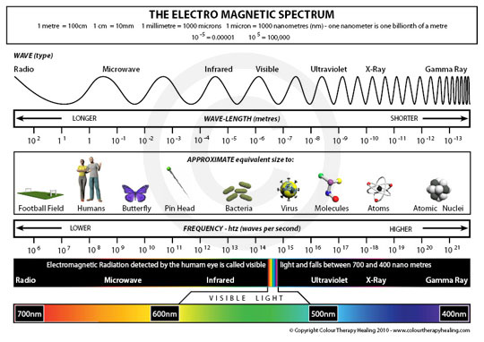

The electromagnetic spectrum includes: **RADIO** and TV, microwave, **INFRARED** (IR, or light with wavelength greater than 700 nm), visible light (with wavelengths between 400nm and 700 nm), ultraviolet (UV, or light with wavelength shorter than 400 nm), X-ray, and **GAMMA**.

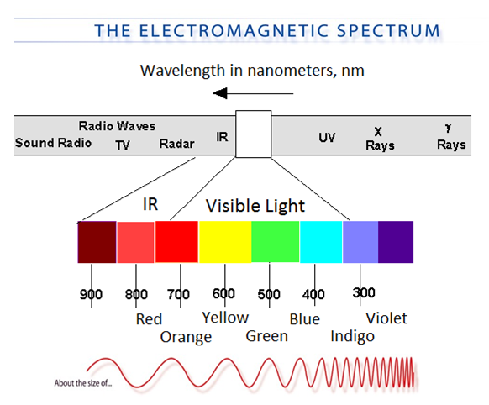

* Light exhibits behaviors which are characteristics of both waves and particles.
* Light acts like a particle when it transfers or absorbs energy; light acts like a wave when it moves through space.
* All EM waves travel at the speed of light in a vacuum.

**Sample Problems:**

1. Convert 450 nm to meters.

450 nm 1 x 10-9 m = 4.5 x 10-7 m

1 nm

1. How many km away is a distant star if it takes 4.1 years for its light to reach the Earth?

4.1 yr 365 days 24 hrs 60 min 60 sec = 1.3x108 sec V = d/t

1 yr 1 day 1 hr 1 min 3 x108 = d / 1.3x108 = 3.9x1016 m

3.9 x 1016 m 1 km 3.9 x 1013 km

1000 m

1. How long does it take for light to reach the surface of the Earth, 150 million kilometers away?

150,000,000 km 1000 m 1.5 x 1011 m V = d/t

1 km 3 x108 = 1.5 x1011

time

Time = 1.5 x1011 500 sec

3 x108

VIDEO ON LIGHT

**Reflection:**

1. **DIFFUSE** reflection: light reflected from a rough, textured surface
2. **SPECULAR** reflection: light reflected from smooth, shiny surfaces

* 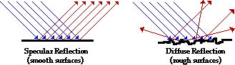The angle of **INCIDENCE** = the angle of **REFLECTION**

**Types of Mirrors**

1. **Plane mirrors**

* Simplest type
* Object size = image size
* Object distance = image distance
* Image is **UPRIGHT** , **VIRTUAL**, the **SAME** size, and has right-to-left reversal

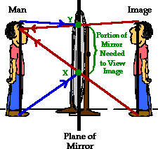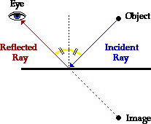The image location can be predicted with ray diagrams

**Steps for drawing a plane mirror ray diagram:**

1. A ray that strikes perpendicular to the mirror surface reflects perpendicular to the mirror. This reflected ray is extended behind the mirror.
2. A ray that strikes the mirror at any angle reflects so that the angle of incidence equals the angle of reflection;
3. the reflected ray is extended behind the mirror.

**Type of images:**

1. **REAL images** - formed by converging light rays; can be projected on a screen; orientation=inverted
2. **VIRTUAL images** - cannot be projected on a screen; orientation=upright

|  |  |
| --- | --- |
| MONDAY  5/2/16 | EOC – NO WARM UP |
| TUESDAY  5/3/16 | Choose all the statements that are **NOT** correct.   * 1. Red light has a shorter wavelength then blue c. Red light has a longer wavelength than blue   2. Red light has a lower frequency than blue d. Red light has a higher frequency than blue |
| WEDNESDAY  5/4/16 | An object in front of a concave mirror inside of F (between F and the mirror) will form what type of image? |
| THURSDAY  5/5/16 | An object in front of a concave mirror located outside of C will form what type of image? |
| FRIDAY  5/6/16 | An object located in front of a convex mirror will form what type of image? |

1. 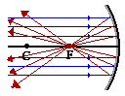**Concave mirrors**

* A **CONVERGING** mirror; light rays that strike the mirror surface are reflected so that they converge, or "come together," at a point
* The reflecting surface of the mirror is on the **INSIDE**; the object and focus are located on the same side of the mirror

**Curved mirror terminology:** (a concave mirror is drawn as an example)

* **CENTER OF CURVATURE (C)**:the center of the circle of which the mirror represents a small arc
* **FOCUS (F)**: the point where parallel light rays converge; the focus is always found on the inner part of the "circle" of which the mirror is a small arc; the focus of a mirror is one-half the radius
* **VERTEX (A)**: the point where the mirror crosses the principal axis
* **PRINCIPAL AXIS** a line drawn through the vertex, focus, and center of curvature of the mirror upon which the object rests
* **FOCAL LENGTH (f)**: the distance from the focus to the vertex of the mirror
* **RADIUS OF CURVATURE (R)**: the distance from the center of curvature to the vertex of the mirror; it corresponds to the radius of the circle

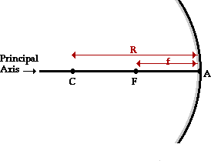

**Characteristics of concave mirrors:**

1. The focal length is **POSITIVE** (because the object and the focus are on the same side of the mirror)
2. Real images can be formed by the mirror when the object is **OUTSIDE** of the focus; an **INVERTED** image is formed
3. Virtual images are formed by the mirror when the object is **INSIDE** the focus; an **UPRIGHT** image is formed
4. No image is formed when the object is **AT** the focus
5. When the object is at the center of curvature, an **INVERTED** image is formed at the **CENTER OF CURVATURE** which is the **SAME DISTANCE** as the object.

**Convex mirrors**

* A **DIVERING**; light rays that strike the mirror surface are reflected so that they diverge, or "go apart," and they never come to a point.

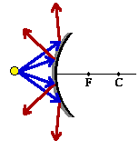

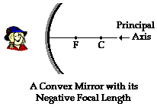

**Characteristics of convex mirrors:**

1. The focal length is **NEGATIVE**
2. The object and the focus are on **OPPOSITE** sides of the mirror (the focus is on the inside of the mirror and the object is on the outside)
3. Only **VIRTUAL** images are formed; all images are smaller than the object (smaller, upright and virtual) **SUV.**

**Summary of Sign Conventions for Spherical Mirrors**

**Focal Length**

* *f* is **POSITIVE** for a concave mirror
* *f* is **NEGATIVE** for a convex mirror

**Object Distance**

* *do* is **POSITIVE** for a real object (the object is in front of the mirror)
* *do* is for a virtual object (the object is behind the mirror)

**Image Distance**

* *di* is **POSITIVE** for a real image (the image is in front of the mirror)
* *di* is **NEGATIVE** for a virtual image (the image is behind the mirror)

**Magnification**

* *M* is **POSITIVE** for an image whose orientation is the same as the object
* *M* is **NEGATIVE** for an image whose orientation is inverted with respect to the object

# Characteristics

* real or virtual
* upright or inverted
* larger or smaller

**CONCAVE MIRRORS**

SIR SSIR

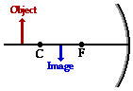 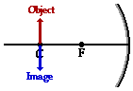

RIL NONE

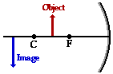 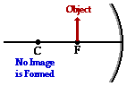

LUV

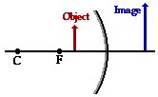

CONVEX MIRROR

SUV

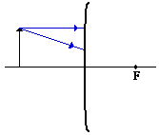

**Mathematical prediction of image location:**

do – Always positive

di – Positive REAL

di – Negative VIRTUAL

$\frac{1 }{f}$ = $\frac{1}{do}+ \frac{1}{di}$

* *f* is the focal length (remember to assign it a sign)
* *do* is the object distance
* *di* is the image distance

**Mathematical prediction of image height and magnification:**

ho – Always Positive

hi – Positive – UPRIGHT

hi – Negative - INVERTED

$$M= \frac{-di}{do} = \frac{hi}{ho}$$

* *hi* is the image height
* *ho* is the object height
* M is the magnification of the image

**Concave Samples:**

1. A child who is 1.2 m tall is standing 6.0 m from a concave mirror with a focal length of 3.0 m. Find di, hi, M and the characteristics.

di = do Standing at C M = hi/ho 1/f = 1/do + 1/di

M = -di/do -1 = hi / 1.2 1/3 – 1/6 = 1/di

M = -6/6 = -1 (-1)(1.2) = hi 2/6 – 1/6 = 1/di

-1.2 = hi 1/6 = 1/di

6/1 = di/1

6 = di

1. An object is located 30.0 cm from a converging mirror with a radius of curvature of 10.0 cm. At what distance from the mirror will the image be formed? If the object is 4.0 m tall, how tall is the image? What is the magnification?

do = 30 1/f =1/do + 1/di M = -di/do M = hi/ho

ho =400 1/5 -1/30 = 1/di M = -6 /30 -.2 = hi/400

C = 10 6/30 – 1/30 = 1/di M = -.2 (-.2)(400) = hi

F = 5 5/30 = 1/di -80 = hi

30/5 = di/1

6 = di

**Concave Practice Problems:**

* 1. A thimble is 27 cm from a concave mirror. The focal point of the mirror is 11 cm. Where is the location of the image? (**+ 18.6 cm)**

do = 27 1/f = 1/do + 1/di

f = 11 1/11 -1/27 = 1/di

C = 22 27/297 – 11/297 = 1/di

16/297 = 1/di

297/16 = di/1

18.6 = di

* 1. An object and its image as seen in a concave mirror are the same height when the object is 41.6 cm from the mirror. What is the focal length of the mirror? **(+20.8 cm)**

hi = ho \* standing at C

C = ½ f

C = (.5)(41.6) = 20.8

* 1. An object 10.9 cm high is located 81.1 cm from a concave mirror that has a focal length of 14.9 cm. Where is the image located and what is its height? **(+18.3 cm , -2.5 cm)**

ho = 10.9 1/f = 1/do + 1/di

do = 81.1 1/14.9 – 1/81.1 = 1/di

f = 14.9 81.1/1208.39 – 14.9 / 1208.39 = 1/di

C = 29.8 66.2/1208.39 = 1/di

1208.39/66.2 = di/1

18.3 = di

M = -di/do M = hi/ho

M = -18.3/81.1 -2.3 = hi/10.9

M = - 2.3 (-2.3)(10.9) = hi

-2.5 = hi

**Concave Examples**

|  |  |  |
| --- | --- | --- |
| **Case 1: A child who is 4 cm tall is standing 9 cm from a concave mirror with a focal length of 4 cm.** | | |
| **Di** | **Hi** | **M** |
| **1//f =1/do + 1/di**  **¼ - 1/9 = 1/di**  **9/36 – 4/36 = 1/di**  **5/36 = 1/di**  **36/5 = di/1**  **7.2 = di** | **M = hi/ho**  **-.8 = hi/4**  **(-.8)(4) = hi**  **-3.2 = hi** | **M = -di/do**  **M = -7.2/9**  **M = -.8** |
| **RAY DIAGRAM** | | |

|  |  |  |
| --- | --- | --- |
| **Case 2: A child who is 4 cm tall is standing 8 cm from a concave mirror with a focal length of 4 cm.** | | |
| **Di** | **Hi** | **M** |
| **1/f = 1/do +1/di**  **¼ - 1/8 = 1/di**  **2/8 – 1/8 = 1/di**  **1/8 = 1/di**  **8/1 = di/1**  **8 = di** | **M = hi/ho**  **-1 = hi/4**  **(-1)(4) = hi**  **-4 = hi** | **M = -di/do**  **M -8/8**  **M = -1** |
| **RAY DIAGRAM** | | |

|  |  |  |
| --- | --- | --- |
| **Case 3: A child who is 4 cm tall is standing 6 cm from a concave mirror with a focal length of 4 cm.** | | |
| **Di** | **Hi** | **M** |
| **1/f = 1/do + 1/ di**  **¼ - 1/6 = 1/di**  **6/24 – 4/24 = 1/di**  **2/24 = 1/di**  **24/2 – di/1**  **12 = di** | **M = hi/ho**  **-2 = hi /4**  **(-2)(4) = hi**  **-8 = hi** | **M - -di/do**  **M = -12/6**  **M = -2** |
| **RAY DIAGRAM** | | |

|  |  |  |
| --- | --- | --- |
| **Case 4: A child who is 4 cm tall is standing 4 cm from a concave mirror with a focal length of 4 cm.** | | |
| **Di** | **Hi** | **M** |
| **1/f = 1/do + 1/ di**  **¼ - ¼ = 1/di**  **0 = 1/di** | **M = hi/ho**  **0 = hi / 4**  **(0)(4) = hi**  **0 = hi** | **M = -di/do**  **M = 0/4**  **M = 0** |
| **RAY DIAGRAM** | | |

|  |  |  |
| --- | --- | --- |
| **Case 5: A child who is 4 cm tall is standing 2 cm from a concave mirror with a focal length of 4 cm.** | | |
| **Di** | **Hi** | **M** |
| **1/f = 1/do + 1/ di**  **¼ - ½ = 1/di**  **¼ - 2/4 = 1/di**  **-1/4 = 1/di**  **-4/1 = di/1**  **-4 = di** | **M = hi/ho**  **(2)(4) = hi**  **8 = hi** | **M = -di/do**  **M = -(-4)/2**  **M = 2** |
| **RAY DIAGRAM** | | |

**Ray diagrams for concave mirrors:**

1. A ray incident upon the mirror that is **PARALLEL** to the principal axis, reflects through the **FOCUS**
2. A ray incident upon the mirror that passes **THROUGH** the focus, reflects **PARALLEL** to the principal axis
3. A ray that passes through C reflects back the same way.
4. The place where the reflecting rays intersect is where the image is formed.

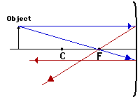

**Concave Diagrams**

**An object is 5 cm from a concave mirror. The center of curvature is 4 cm. The object is 1 cm tall. Find the characteristics.**

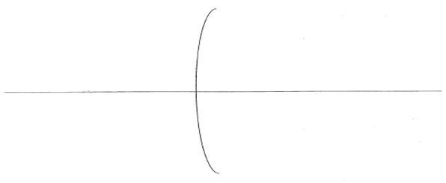

**An object is 3 cm from a concave mirror. The center of curvature is 4 cm. The object is 1 cm tall. Find the characteristics.**



**An object is 2 cm from a concave mirror. The center of curvature is 4 cm. The object is 1 cm tall. Find the characteristics.**



**Convex Sample:**

1. A diverging mirror with a focal length of 5.0 cm produces and image of an object located 15.0 cm from the mirror. What is the distance of the image from the mirror? What is the magnification? Note: The same equations work for both concave and convex mirrors.

F = -5 1/-f = 1/do + 1/di M = -di/do

do = 15 1/-5 -1/15 = 1/di M = - (-3.75)/15

-3/15 – 1/15 = 1/di M = .25

-4/15 = 1/di

-15/4 = di/1

-3.75 = di

**Convex Practice Problems:**

1. A convex mirror has a focal length of -13 cm. How far behind the mirror does the image of a person standing 3 m in front appear? **(-12.5 cm)**

F = -13 1/-f = 1/do + 1/di

do = 300 1/-13 – 1/300 = 1/di

-300 /3900 – 13/3900 = 1/di

-313 /3900 = 1/di

1. -313 = di /1

-12.46 = di

1. How far behind the surface of a convex mirror, focal length of -5 cm, does a car 17 m from the mirror appear? **(-4.99 cm)**

F = -5 1/-f = 1/do + 1/di

do = 1700 1/-5 – 1/1700 = 1/di

-1700 / 8500 – 5/8500 =1/di

-1705/8500 = 1/di

8500/-1705 = di/1

-4.99 = di

**Convex Mirrors**

|  |  |  |
| --- | --- | --- |
| **A child who is 4 cm tall is standing 2 cm from a convex mirror with a focal length of 4 cm.** | | |
| **Di** | **Hi** | **M** |
| **1/-f = 1/do + 1/di**  **1/-4 – ½ = 1/di**  **1/-4 – 2/4 = 1/di**  **-3/4 = 1/di**  **-4/3 = di/1**  **-1.33 = di** | **M = hi/ho**  **.66 = hi/4**  **(.66)(4) = hi**  **2.64 = hi** | **M = -di/do**  **M = -(-1.33)/2**  **M = .66** |
| **RAY DIAGRAM** | | |

**Convex Mirrors**

|  |  |  |
| --- | --- | --- |
| **A Toy which is 5 cm tall is standing 4 cm from a convex mirror with a focal length of 8 cm.** | | |
| **Di** | **Hi** | **M** |
| **1/-f = 1/do + 1/di**  **1/-8 - 1/4 = 1/di**  **1/-8 – 2/8 1/di**  **3/-8 = 1/di**  **-8/3/ di/1**  **-2.66 = di** | **M = hi/ho**  **.66 = hi/3**  **(.66)(3) = hi**  **3.3 = hi** | **M = - di/do**  **M = -(-2.66)/4**  **M .66** |
| **RAY DIAGRAM** | | |

**Ray Diagrams for convex mirrors:**

1. A ray incident on the mirror that is parallel to the principal axis is reflected in a line even with the focus (extend the reflected ray behind the mirror so that it passes through the focus)
2. A ray incident on the mirror that passes through the focus is reflected parallel to the principal axis (extend the reflected ray behind the mirror parallel to the principal axis)
3. A ray that passes through C reflects back the same way.

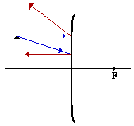

**CONVEX DIAGRAMS**

**An object is 2 cm from a convex mirror. The center of curvature is 6 cm. The object is 3 cm tall. Find the characteristics.**



PRACTICE PROBLEMS

**An object is 6.0 cm in front of a concave mirror. The mirror has a radius of curvature of 8.0 cm. If the object has a height of 3.0 cm, determine the location, height, and characteristics of the image produced.**

di = hi = Real or Virtual

Inverted or Upright M =

**An object is 10.0 cm in front of a concave mirror. The mirror has a radius of curvature of 8.0 cm. If the object has a height of 3.0 cm, determine the location, height, and characteristics of the image produced**

di = hi =

Real or Virtual Inverted or Upright

M =

**An object is 6.0 cm in front of a convex mirror. The mirror has a radius of curvature of 6.0 cm. If the object has a height of 3.0 cm, determine the location, height, and characteristics of the image produced.**



di = hi = Real or Virtual

Inverted or Upright M =

**PRACTICE DAY PROBLEMS**

1. What is the speed of light? What variable is represents the speed of light?

**3x108 m/s The Variable is “c”**

1. What are the characteristics of a plane mirror?

**The do == di Upright and virtual**

**The hi = ho Left hand & Right hand reversal**

1. What is another name for a concave mirror? Convex mirror?

**Concave is called Converging**

**Convex is called Diverging**

1. What wavelengths of light fall into the visible light range?

**Red ------------------------------------------------------------------- Violet**

**700 nm 400 nm**

1. Describe each variable below in terms of a positive value or a negative value. An example has been given below.

|  |  |  |
| --- | --- | --- |
|  | **Positive** | **Negative** |
| **Focal Length** | **Concave mirror** | **Convex Mirror** |
| **Object Distance (Do)** | **Concave & Convex** |  |
| **Image Distance (Di)** | **Real Image** | **Virtual Image** |
| **Magnification** | **Image upright** | **Image Inverted** |

1. A 2 cm tall object is placed 6 cm in front of a concave mirror that has a focal length of 30 cm. Where is the image located? How tall is the image? What is the magnification? Characteristics

1/f =1/do + 1/di M = -di/do M = hi/ho

1/30 – 1/6 = 1/di M = -(-7.5) / 6 1.25 = hi/2

1/30 – 5/30 = 1/di M = 1.25 (1.25)(2) = hi

-4/30 = 1/di 2.5 = hi

30/-4 = di/1

-7.5 = di

LUV

1. A 6 cm high object is placed 8 cm in front of a convex mirror that has a focal length of -15 cm. Where is the image located? How tall is the image? What is the magnification? Characteristics?

1/-f = 1/do + 1/di M = -di/do M = hi/ho

1/-15 – 1/8 = 1/di M = -(-5.2)/8 .65 = hi/6

-8/120 – 15/120 = 1/di M = .65 (.65)(6) = hi

-23/120 = 1/di 3.9 = hi

120/-23 = di/1

-5.2 = di

SUV

1. Fill in the chart below with the correct acronym and sketch. Include F, C, Do, Di, Ho and Hi in your sketch.

|  |  |  |  |
| --- | --- | --- | --- |
| **Concave Mirror** | | | |
| **Acronym** | **Image** | **Acronym** | **Image** |
| **SIR** |  | **LUV** |  |
| **SSIR** |  | **NO IMAGE** |  |
| **RIL** |  |  |  |
| **Convex Mirror** | | | |
| **SUV** |  | | |

|  |  |
| --- | --- |
| MONDAY  5/9/16 | Why does a straw look bent in a glass of water?  The speed of light changes as it enters different mediums |
| TUESDAY  5/10/16 | If light bends towards the normal, is it speeding up or slowing down?  It is slowing down. It has entered a more dense medium |
| WEDNESDAY  5/11/16 | The following picture depicts light moving from water into air. Water has an index of refraction of 1.33. At what approximate speed will the light move through the water?  n = c/v 1.33 = 3x108 / v v = 3x108/1.33 2.25x108 m/s |
| THURSDAY  5/12/16 | Light travels through air and strikes a smooth water surface. The speed of light in water is 2.25 x 108 m/s. If the refracted angle of light in the water is 34°, what is the index of refraction of water?  n = c/v  n = 3x108 / 2.25x108  n = 1.33 |
| FRIDAY  5/13/16 | QUIZ |

**REFRACTION NOTES**

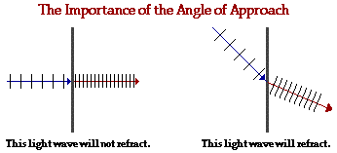**Refraction**

The **BENDING** of light as it enters a medium of different optical density; light is refracted only when it hits a boundary at an **ANGLE.** It is not refracted if it strikes **PERPENDICULAR** to the boundary.

**Angle of Refraction**

* The angle the refracted ray makes with the **NORMA**L**.**
* 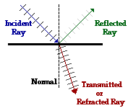When light enters a **MORE** optically dense medium, its speed is **REDUCED.** The angle of refraction is **LESS** than the angle of incidence. The refracted ray is said to be bent "**TOWARDS** the normal."



Normal

* When light enters a **LESS** optically dense medium, its speed is **INCREASED.** The angle of refraction is **GREATER** than the angle of incidence. The refracted ray is said to be bent “**AWAY** from the normal."
* The optical **DENSITY** of a medium determines the speed of light in that medium.

**Index of refraction**

* A **CONSTANT** that is characteristic of the substance. It is the ratio of the speed of light in a vacuum to the speed of light in that substance. Its variable is *n* and it **NO UNITS**.

*n* = index of refraction

**n = c/v**

*c* = speed of light in a vacuum

*v*  = speed of light in the medium.

* The index of refraction of a vacuum (approximately air) is: **n = 1.00**
* When light enters a more optically dense medium, its **WAVELENGTH** is also reduced. The frequency of the light is **constant.** The wavelength in the medium is given by

**λmedium = λvacuum/nmedium**

**Sample 1: The speed of light in a liquid is 2.25 x 108 m/s. What is the refractive index (n) of the liquid? (1.33)**

**n = c/v 3x108  / 2.25 x108 = 1.33**

**Sample 2: If the index of refraction for water is 1.33, what is the speed of light in water? (2.26 x 108 m/s)**

**n = c/v 1.33 = 3x108 / v**

**v = 3x108 / 1.33 = 2.26x108 m/s**

**Practice 1: The speed of light in a liquid is 2.7x108 m/s. What is the refractive index of the liquid? (1.11)**

**n = c/v 3x108 / 2.7x108 = 1.11**

**Practice 2: If the index of refraction for a liquid is 1.5, what is the speed of light in that liquid? (2 x 108 m/s)**

**n = c/v 1.5 = 3x108 / v**

**v = 3x108 / 1.5 = 2x108 m/s**

**Snell's law**

* 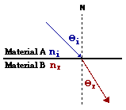Snell's law states that the ratio of the sine of the angle of incidence to the sine of the angle of refraction is a **constant** (or the ratio of the indices of refraction of the two mediums).
  + n1 = index of refraction of the incident medium
  + n2 = index of refraction of the refractive medium
  + Θ1 = angle of incidence
  + Θ2 = angle of refraction
* **Note: n ≈ 1 for air**

**Sample 1: Light travels from crown glass into air. The angle of refraction in air is 600. What is the angle of incidence in glass if n of glass = 1.52? (34.73˚)**

**n1 sin ϴ = n2 sin ϴ ϴ = .569 sin-1**

**1.52 sin ϴ = 1 sin 60 = 34.7 o**

**Sin ϴ = 1 sin 60**

**1.52**

**Sin ϴ = .569**

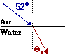

**Sample 2: What is the angle of refraction in the picture if *n* for water equals 1.33? (36.3˚)**

**1 sin 52 = 1.33 sin ϴ .5925 sin-1 = ϴ**

**1 sin 52 = sin ϴ**

**1.33**

**.5925 = sin ϴ 36.6 o = ϴ**

**Practice 1: Light travels through a lollipop into the air. The angle of refraction in air is 55o. What is the angle of incidence in the lollipop if n of the lollipop = 1.48? (33.6˚)**

**1.48 sin ϴ = 1 sin 55 sin ϴ = .5535**

**Sin ϴ = 1 sin 55 ϴ = .5535 sin-1 = 33.6o**

**1.48**

**Critical angle**

* 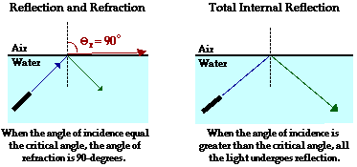This is the angle of incidence in the more optically dense medium at which **TOTAL INTERNAL REFLECTION** occurs. At this angle of incidence, the angle of refraction in the less optically dense medium is exactly **90o**.
* For the picture to the right, n1 is the air and n2 is the water, which makes the critical angle Θ1.

**Total internal reflection**

* Total internal reflection occurs when light falls on a surface of a less optically dense medium at an angle of incidence equal to or greater than the **CRITICAL ANGLE** of the substance. There is no **REFRACTED** ray; the angle of refraction is **90o** or greater.
* Total internal reflection only occurs when a light ray passes from a **MORE** optically **DENSE** substance into a **LESS** optically **DENSE** substance. Total internal reflection is the principle behind fiber optics and binoculars.
* **Note: When not told otherwise, assume the second (less dense) medium is air; n ≈ 1.**

**Sample 1**: What is the critical angle for light traveling from water (n=1.33) into air? (48.75˚)

1.33 sin ϴ = 1 sin 90 ϴ = .7519 sin-1

1.33 sin ϴ = 1 ϴ = 48.7 o

Sin ϴ = 1 /1.33

Sin ϴ = .7519

**Sample 2**: The critical angle for a medium is 40.50. What is the index of refraction of the medium? (1.54)

**n sin 40.5 = 1 sin 90**

**n = 1/sin 40.5**

**n = 1.54**

**Practice 1**: What is the critical angle for light traveling from a diamond (n=2.42) into air? (24.41˚)

2.42 sin ϴ = 1 sin 90 ϴ = .41 sin-1

Sin ϴ = 1 / 2.42 ϴ = 24.4o

Sin ϴ = .41

**Practice 2**: The critical angle for a medium is 320. What is the index of refraction of the medium? (1.89)

**N sin 32 = 1 sin 90**

**N = 1 / sin 32**

**N = 1.89**

**LENSES NOTES**

Any transparent object having two nonparallel **CURVED** surfaces, or having one plane surface and one **CURVED** surface. A lens creates an image by **REFRACTING** light.

**Types of lenses:**

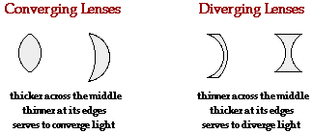

* **Convex lens (converging lens)**
  1. A convex lens is **ALWAYS THICKER** in the center than at the edges.
  2. Light traveling through the lens goes **SLOWER** through the thick center and

**FASTER** through the thin ends causing the rays to focus or converge.

* 1. The focal length of a convex lens is always **POSITIVE**.
  2. Real images are produced when the object is **OUTSIDE** of the focus.
  3. No image is produced when the object is **AT** the focus.
  4. Virtual images are produced when the object is **WITHIN** the focus.
* **Concave lens (diverging lens)**

1. A concave lens is **ALWAYS THINNER** in the middle than at the edges.
2. Light traveling through a concave lens goes **FASTER** through the center and

**SLOWER** through the ends. This causes the rays to diverge or not to focus.

1. The focal length of a concave lens is always **NEGATIVE**.
2. Only **VIRTUAL** images are produced by a concave lens.

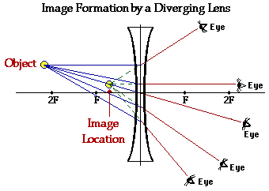

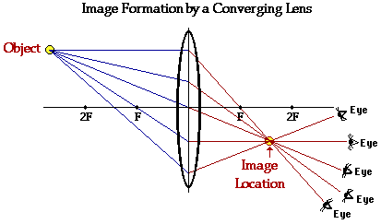

**Lens Equations**

$\frac{1}{F}= \frac{1}{do}+ \frac{1}{di}$ $M= \frac{hi}{ho}= -\frac{di}{do}$

**Optical Instruments**

* 1. Camera - a camera contains a convex lens which focuses a **REAL** image on the film.
  2. Human eye - contains a **CONVEX** lens which focuses an image on the retina.
     + - 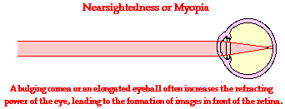Nearsightedness (or **MYOPIA**) occurs when the eye can only focus on close objects; it is usually caused by an eyeball which is too long. It can be corrected with a **DIVERGING** lens.

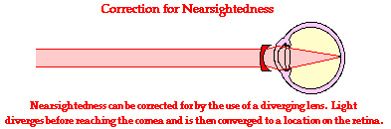

* + - * Farsightedness (or **HYPEROPIA)** occurs when the eye can only focus on distance objects; it is usually caused by an eyeball which is too short. It can be corrected with **CONVERING** lens.

1. 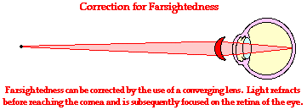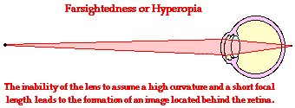Astigmatism is caused by an out-of-round cornea or lens
   1. Magnifying glass - a converging lens with the object distance less than the focal length; a **VIRTUAL**, magnified image is produced.
   2. Telescope - Magnifies distant objects; the refracting telescope consists of **TWO CONVEX** lenses. The focal length of the lens used as the eyepiece is small and that of the objective lens is large.
   3. Compound Microscope - magnifies objects which are close. The focal length of the lens used as the eyepiece is large and that of the objective lens is small.

**Sign Conventions for Thin Lenses**

**Focal Length**

1. *f* is **(** + **)** for converging lenses **( CONVEX )**
2. *f* is **(** - **)** for diverging lenses **( CONCAVE )**

**Object Distance**

1. *d*o is **(** + **)** if the object is on the **SAME SIDE** of the lens from which the light is incident
2. *d*ois **(** - **)** if the object is on the **OPPOSITE SIDE** of the lens from which the light is incident

**Image Distance**

1. *d*i is **(** + **)** if the image is on the **OPPOSITE SIDE** of the lens from which the light is incident; *d*i is **(** + **)** for a real image
2. *d*i is **(** - **)** if the image is on the **SAME SIDE** of the lens from which the light is incident; *d*i is **(** - **)** for a virtual image

**Object Height**

1. *h*o is always **(** + **)**

**Image Height**

1. *h*i is **(** + **)** if the image is upright
2. *h*i is **(** - **)** if the image is inverted

**Sample 1**: An object is placed 5 cm in front of a convex lens that has a focal length of 2.75 cm. The height of the object is 2.0 cm.

a) Find the image distance, di. (6.11 cm)

b) Find the image height, hi. (- 2.44 cm)

c) What are the image characteristics (acronym)? (RIL)

1/f = 1/do + 1/di M = -di/do M = hi/ho

1/2.75 – 1/5 = 1/di M = - 6.11/5 -1.22 = hi / 2

5 / 13.75 – 2.75/13.75 =1/di M = -1.22 (-1.22)(2) = hi

2.25/13.75 = 1/di -2.44 = hi

13.75 / 2.25 = di/1

6.11 = di

**Practice 1**: A convex lens with a focal length of 8.0 cm is held 5.0 cm from an insect, which is 1.0 cm tall.

a) Where is the image of the insect located? (- 13.3 cm)

b) How large does the insect appear to be? (2.66 cm)

c) What are the image characteristics (acronym)? (LUV)

**1/f = 1/do + 1/di M = -di/do M = hi/ho**

**1/8 – 1/5 = 1/di M = -(-13.3)/5 2.67 = hi/1**

**5/40 – 8 / 40 = 1/di M = 2.67 (2.67)(1) = hi**

**-3/40 = 1/di 2.67 = hi**

**40/-3 = di/1**

**-13.3 = di**

**Convex Lenses**

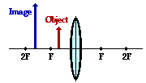**LUV**: do is (+), di is (–), ho is (+) and hi is (+) **RIL:** do is (+), di is (+), ho is (+) and hi is (-)

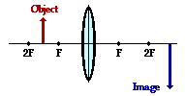

**SIR:** do is (+), di is (+), ho is (+) and hi is (-) **No Image**

**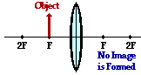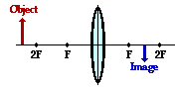**

**Same Size, Inverted and Real**

do is (+), di is (+), ho is (+) and hi is (-)

**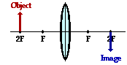**

**Concave Lens**

**SUV:** do is (+), di is (-), ho is (+) and hi is (+)

Image

Image

Image

Object

Object

Object

F

2F

2F

F

2F

2F

F

F

2F

2F

F

F

**REFRACTION PRACTICE**

1. Refraction occurs when \_\_\_\_\_\_\_\_\_.

a. light strikes the boundary of two media that have the same density

b. the angle of reflection equals zero

c. the angle of incidence equals zero

d. light travels through two media that have different densities

2. When light rays travel from one medium into a less dense medium, \_\_\_\_\_\_\_\_\_\_\_\_\_.

a. the refracted rays bend toward the normal

b. the angle of refraction is smaller than the angle of incidence

c. the angle of incidence equals the angle of refraction

d. the rays speed up

3. (True / False) The angle of incidence is always *less than* the angle of reflection.

4. (True / False) The higher the index of refraction is, the *faster* is the speed of light in the substance.

5. (True / False) For most practical purposes, the index of refraction of the air can be considered equal to *1.00*.

6. (True / False) A vacuum has an index of refraction that is *larger* than that of any substance.

7. A light ray enters a substance from the air at an angle of 34º. The light is refracted inside the substance and

travels at an angle of 25º. What is the index of refraction of the substance? **[1.32]**

1 sin 34 = n sin 25

1 sin 34 = n

Sin 25

1.32 = n

8. The index of refraction of a substance is 2.27. What is the speed of light in that material?

**[1.32x108 m/s]**

N = c/v v = 3x108 v = 1.32x108 m/s

2.27

2.27 = 3x108

v

9. A ray of light passes from an unknown substance into the air. If the angle in the unknown substance is 35.0º

and the angle in the air is 49.0º, what is the index of refraction of the unknown substance? **[1.32]**

n sin 35 = 1 sin 49

n = 1 sin 49

sin 35

n = 1.32

10. A ray of light in air has an angle of incidence of 37.0º upon the surface of a piece of quartz ( n=1.45).

What is the angle of refraction? **[24.8°]**

1 sin 37 = 1.45 sin ϴ

1 sin 37 = sin ϴ

1.45

.42 = sin ϴ

.42 sin-1 = ϴ = 24.8 o

11. Find the speed of light in antimony trioxide if it has an index of refraction of 2.35. **[1.28 x 108 m/s]**

**N = c/v**

**2.35 = 3x108**

**V**

**V = 3x108 / 2.35 = 1.28x108 m/s**

12. The speed of light in a special piece of glass is 1.69 x 108 m/s. What is its index of refraction? **[1.78]**

N = c/v

N = 3x108

1.69x108

N = 1.78

13. How does the angle of refraction compare to the angle of incidence as a light ray passes from one medium into another with a lower index of refraction?

The higher the “n” value the slower the velocity. Slow Velocity means small Angle.

nI < nR Angle I > Angle R Velocity I > Velocity R

14. The index of refraction for blue light in glass is slightly higher than that for red light in glass. What does this indicate about the relative speeds of red light and blue light in glass.

N blue > N red Θ blue < Θ red V blue < V red

15. Light travels from medium A to medium B. The angle of refraction is greater than the angle of incidence.

a. Which medium has the higher index of refraction? ΘI < ΘR

b. In which medium does the light travel at a lower speed? NI > NR

VI < VR

16. Where would you aim to successfully spear a fish for dinner?

a) At the fish c) Below the fish

b) Above the fish d) Plan on eating meat because you ain’t gonna spear that fish

17. If nwater = 1.33, calculate the speed of light in water. **[2.26 x 108 m/s]**

n = c/v 1.33 = 3x108 / V

V = 3x108 / 1.33

V = 2.26x108 m/s

18. A ray of light passes from air into water at an angle of incidence of 45º. Determine the angle of refraction

in the water. (nwater = 1.33) **[32°]**

1 sin 45 = 1.33 sin Θ

1 sin 45 = sin Θ

1.33

.53 = sin Θ

Sin-1 .53 = Θ = 32o

19. The angles of incidence and refraction for light going from air into a more dense material are 50º and 35º

respectively. What is the index of refraction of this material? **[1.34]**

1 sin 50 = n sin 35

1 sin 50 = n

Sin 35

1.34 = n

20. When light goes from a less dense to a more dense material, is the angle of refraction larger or smaller

than the angle of incidence? **nI < nR ΘI > ΘR VI > VR**

**LENSES PRACTICE**

1. Generally speaking, lenses \_\_\_\_\_\_\_\_\_\_ light while mirrors \_\_\_\_\_\_\_\_\_\_\_ light.

a. Reflect, Refract c. Diffract, Reflect

b. Refract, Reflect d. Refract, Diffract

1. Concave lenses are also known as \_\_\_\_\_\_\_\_\_\_\_\_\_\_\_ lenses.
   1. Diverging b) Converging c) Magnifying d) Polarizing
2. Convex lenses are also known as \_\_\_\_\_\_\_\_\_\_\_\_\_\_\_ lenses.
   1. Magnifying b) Polarizing c) Diverging d) Converging
3. **The speed of light in a liquid is 1.7x108 m/s. What is the refractive index of the liquid? (1.76)**

**n = c/v n = 3x108 / 1.7x108**

**n = 1.76**

1. **If the index of refraction for a liquid is 1.34, what is the speed of light in that liquid? (2.23x108 m/s)**

**n = c/v**

**1.34 = 3x108 / v**

**v = 3x108 / 1.34 = 2.23 x108 m/s**

1. What is the critical angle for light traveling from a piece of amber (n=1.54) into air? **(40.5o)**

1.54 sin Θ = 1 sin 90 Θ = sin-1 .65

Sin Θ = 1 / 1.54 Θ = 40.5 o

Sin Θ = .65

1. The critical angle for a medium is 720. What is the index of refraction of the medium? **(1.05)**

n sin 72 = 1 sin 90

n = 1 / sin 72

n = 1.05

1. An object is placed 32 cm in front of a convex lens that has a focal length of 8.0 cm. The height of the object is 3.0 cm.
   1. Find the image distance, di. **(11 cm)**
   2. Find the image height, hi. **(-1.0 cm)**
   3. What are the image characteristics **(SIR)?**

1/f = 1/do + 1/di M = -di/do M = hi/ho

1/8 – 1/32 = 1/do M = -10.6 /32 -.33 = hi/3

4/32 – 1/32 = 1/do M = - .33 (-.33)(3) = hi

3/32 = 1/di -.99 = hi

32/3 = di/1

10.6 = di

SIR

1. A convex lens with a focal length of 6.0 cm is held 4.0 cm from an insect, which is 0.50 cm tall.
   1. Where is the image of the insect located? (-12 cm)
   2. How large does the insect appear to be? (1.5 cm)
   3. What are the image characteristics (LUV)?

1/f = 1/do + 1/di M = -di/do M = hi/ho

1/6 – ¼ = 1/di M = -(-12)/4 3=hi/.5

4/24 – 6/24 = 1/di M = 3 (3)(.5) = hi

-2/24 = 1/di 1.5 = hi

24/-2 = di/1

-12 = di

LUV

|  |  |
| --- | --- |
| MONDAY  5/16/16 | Is light a particle or a wave?  Light has properties of both a particle and a wave |
| TUESDAY  5/17/16 | What is the energy of a photon whose wavelength is 450 nm?  c = fΛ E = hf  3x108 = f(450x10-9) E = (6.63x10-34)(6.67X1014)  3x108/450x10-9 = f E = 4.42x10-19 J  f = 6.67x1014 |
| WEDNESDAY  5/18/16 | |  | | --- | | **The work function for a certain metal is 5.2 eV.** | | 1. What is the threshold frequency for this metal?   KE = hf - Ф  0 = (4.14x10-15)fo - 5.2  5.2 = (4.14x10-15)fo  5.2 / 4.14x10-15 = fo = 1.25 x1015 Hz | | 1. Which of the following frequencies would emit electrons from the metal?   8 x 1014 Hz b. 9 x 1015 Hz c. 10 x 1015 Hz  Both are greater than 1.25 x1015 Hz | |
| THURSDAY  5/19/16 | A metal whose work function is 4 eV is struck with light of frequency 6.2 x 1015 Hz. What is the max kinetic energy of photoelectrons ejected from the metal's surface?  KE=hf - Ф  KE = (4.14x10-15)(6.2x1015) – 4  KE = 22 eV |
| FRIDAY  5/20/16 | An electron that was emitted from a photoelectric experiment is measured to have a kinetic energy of 5.4 x 10-19 J. What is the velocity of this electron?  KE = ½ mv2  5.4x10-19 = ½ (9.11x10-31)v2  √(2)( 5.4x10-19)/ 9.11x10-31 = v  1.1x106 m/s = v |

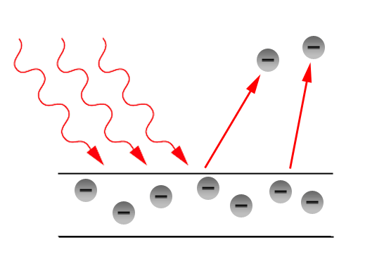

**The Electron and Planck’s Quantum Hypothesis**

**Twentieth Century – physics of the very small**

* The particle-like nature of light was revealed and studied through the work of Max Planck in 1900, and later by Albert Einstein.

**Quantum Mechanics**

* The study of processes which occur at the atomic scale (the size of atoms and smaller).
* The word “quantum” is derived from Latin to mean BUNDLE
* At the atomic scale, Newton’s Laws cannot seem to describe the motion of particles.
* Where Newton’s Laws ends Quantum Mechanics takes over

**Planck’s Quantum Hypothesis**

* **Quantum –** an elemental unit – a smallest amount of something
  + **Ex:** matter is quantized. The mass of a gold ring is equal to some whole-number multiple of the **MASS** of a single gold atom.
  + Electricity is quantized as all electric charge is some whole-number multiple of the **CHARGE** of a single electron
  + The energy of a light beam is **ALSO QUANTIZED**
* Electromagnetic radiation is emitted and absorbed by matter as though it existed in individual bundles called **quanta**

E = hf

where h = **6.63 x 10-34 Js**

and f is the frequency of light.

**Photoelectric Effect**

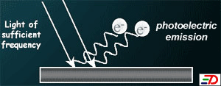

**Photoelectric Effect**

* When light strikes a surface of a material, electrons are emitted**.**
* The light energy supplies the work necessary to free the electrons from the surface
* Evidence that light is made up of particles
* Within a metal, many of the electrons are **FREE** to move around not bound to any one particular atom. They cannot simply fly out of the surface. The need a minimum amount of energy to escape.

**Four basic facts to understand the photoelectric effect**

1. The LIGHT ENERGY (E) is in the form of quanta called PHOTONS.

* **Photons:** a quantum of electromagnetic energy (smallest piece of light waves/particles)
  + Photons move at one speed only, the speed of light (c = 3 x 108m/s)
  + The total energy of a photon is the same as its kinetic energy
  + This kinetic energy is directly proportional to the photon’s frequency
  + Light is not emitted continuously, but as a stream of photons, each with an energy *hf*
* E = energy in J

E = *hf*

* h = Planck’s constant. 6.63 x 10-34 J•s
* f = frequency
  + The energy of multiple photons would be: E = n*hf* (n = an integer: 1, 2, 3, …)
  + This equation gives the smallest amount of energy that can be converted to light of frequency f
* When the energy of a photon is divided by the frequency (*E/f* ), the quantity that results is always the same, no matter what the frequency is. This quantity is known as **Planck’s constant**, h
  + h = 6.63 x 10-34 J•s
  + **Electron volt (eV)** - the amount of energy needed for one electron to move through a potential difference of one volt. An electron volt can be easily converted into Joules. This conversion is useful because the energy values for atoms are so small!

1 eV = 1.6 x 10-19J

So therefore:

* + h = 6.63 x 10-34 J·s = **4.14 X 10-15** eV·s

1. The frequency of radiation must be above a certain value before the energy is enough. This minimum frequency required by the source of electromagnetic radiation to just liberate electrons from the metal is known as **threshold frequency, f0. ( IT IS NOT MOVING)**

**KE = 0**

1. **Work function (**Ф**)** is defined as the minimum amount of energy needed to eject a free electron from the surface of the metal, against the attractive forces of surrounding positive ions.

* This energy is usually expressed in electron volts (it's easier!)

**4.** Energy conservation must be honored.



**E**

**Kmax**

***Φ***

Before Collision After Collision

E (photon striking surface) = Kmax (ejected e-) + Ф (work function)

Kmax = *E –* Ф

but *E* = *hf*

Kmax = *hf* - Ф

The MAXIMUM KINETIC ENERGY is the energy difference between the energy of the photon and the MINIMUM AMOUNT of energy needed (ie. the work function) to eject the electron. This is known as the **photoelectric equation.**

**Samples:**

1. Calculate the energy of the following in Joules and eVs:
   1. a photon of blue light with a frequency of 6.67 x 1014 Hz. (2.76 eV or 4.42 x 10-19 J)

E = hf

(6.63x10-34)(6.67x1014) = 4.42x10-19 J 1 eV 2.76 eV

1.6x10-19 J

* 1. a photon of red light with a wavelength of 630 nm. (1.97 eV or 3.16 x 10-19 J)

E = hf

E = h (c/v)

E = 6.63x10-34 (3x108 / 630x10-9)

E = 3.16x10-19 J 1 eV = 1.97 eV

1.6x10-19 J

1. Light with a wavelength of 600 nm is directed at a metallic surface with a work function of 1.60 eV. Calculate:
2. the energy of the incident light.

E = hf

E = h (c/v)

E = 6.33x10-34 (3x108/600x10-9)

E= 3.3x10-19 J

3.3x10-19 J 1 eV = 2.07 eV

1.6x10-19 J

1. the maximum kinetic energy, in joules, of the emitted electrons. (7.55 x 10-20 J)

KE = hf - Ф

2.07 eV – 1.60 eV = .47 eV 1.6x10-19 J 7.52x10-20 J

1 eV

1. the incoming photon's speed.

3 x108 m/s

1. the ejected electron's maximum speed. (4.1 x 105 m/s)

KE = ½ mv2

7.52x10-20 = ½ (9.11x10-31)(v2)

(2)( 7.52x10-20) = v2

9.11x10-31

1.65x1011 = v2

√1.65x1011 = v

4.1x105 m/s = v

1. The work function for aluminum is 4.08 eV.
   1. What is the threshold frequency required to produce photoelectrons from aluminum? (9.85 x 1014 Hz)

KE =0\*\*\* threshold frequency

KE = hfo – Ф

0 = (4.14x10-15)fo – 4.08

4.08 = (4.14x10-15)fo

4.08 / 4.14x10-15 = fo

9.85x1014 Hz = fo

* 1. If light of frequency f = 4.00 x 1015 Hz is used to illuminate a piece of aluminum,

1. will this light eject electrons? How can you tell?

YES f > fo 4x1015 > 9.85x1014

1. what is the energy of the incoming light?

E = hf

E = (6.63x10-34)(4x1015) = 2.64x10-18 J 1 eV = 1.65 eV

1.6x10-19 J

1. what is Kmax, the maximum kinetic energy of ejected photoelectrons? (12.5 eV or 2 x 10-18 J)

KE = hf - Ф

KE = 16.5 – 4.08 = 12.5 eV 1.6x10-19 J = 2x10-18J

1eV

1. what is the maximum speed of the photoelectrons? (e- mass = 9.11 x 10-31 kg) (2.1 x 106 m/s)

KE = ½ mv2

2x10-18 = ½ (9.11x10-31)v2

(2)(2x10-18) = v2

9.11x10-31

√4.39x1012 = V = 2.1x106 m/s

**Bohr model of the atom (1913)**

* Bohr hypothesized that electrons moved around the nucleus in orbits and made the following four suggestions:
  1. Only certain orbits were allowed. Electrons in each orbit would contain a definite amount of energy and could move in the orbit without radiating energy.
  2. An electron can be **excited** from one energy level to another by a **collision** with another particle or by **ABSORBING** a quantum of electromagnetic radiation.
  3. When an electron **falls** from one energy level to a lower level, it **EMITS LIGHT**, orloses one quantum of electromagnetic radiation.
  4. The energy possessed by the photon is the difference between the final and initial energy levels of the electron.

**λ = *hc* or ∆E = hc/λ**

**ΔE**

**hf = ΔE**

or in terms of wavelength

* 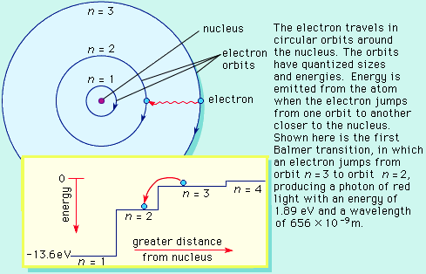Bohr proposed that allowed orbits have quantum numbers (n) of 1, 2, etc. The lowest energy level, or ground state, corresponded to n = 1. Both the orbits and the energy are quantized.

The electron travels in circular orbits around the nucleus. The orbits have quantized sizes and energies. Energy is emitted from the atom when the electron jumps from one orbit to another close to the nucleus. Shown here is an electron jumping from orbit n = 3 to orbit n = 2, producing a photon of light with an energy of 1.89 eV and a frequency of \_\_\_\_\_\_\_\_\_ Hz.

1.89 eV = (4.14x10-15)f

1.89 / 4.14x10-15) = f

4.57x10-14 Hz = f

To help visualize the atom, think of it like a set of stairs. The bottom of the stairs is called **GROUND** **STATE** where all electrons would like to exist.

If energy is **ABSORBED** the electron moves to a new energy level called an **EXCITED** **STATE**. This state is AWAY from the nucleus. ( UP)

If an electron is **EXCITED**, that means energy is **ABSORBED** and therefore a PHOTON is absorbed.

As energy is **RELEASED** the electron can relax by moving to a new energy level down the stairs.

If an electron is **DE-EXCITED**, that means energy is **RELEASED** and therefore a PHOTON is released.

Since a PHOTON is emitted that means that it must have a certain frequency.

Electrons that absorb energy and are excited above the ground state will eventually fall back to the ground state and give off that energy. They can do this by falling through any combination of states.

Sometimes the electron jumps more than once. It is very common that when a particular element takes in energy that the electrons will jump from different orbits.

Since the orbits all exist at DIFFERENT energy levels the photons that are emitted will all have DIFFERENT wavelengths.

To represent these energy transitions we can construct an ENERGY LEVEL DIAGRAM like the one below:

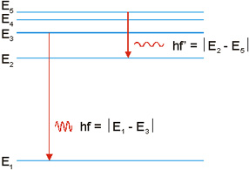

**ground state**

**excited state**

**excited state**

**excited state**

**excited state**

* 1. How does the wavelength of the emitted photon compare when the electron falls from n = 5 to n = 2 versus n = 3 to n = 1? Is this atom giving off energy or absorbing it? How can you tell?

**Binding energy or ionization energy**: The minimum energy required to remove an electron from its **GROUND**  state.

Sample Problems:

1. Consider the energy level diagram given below. Calculate the wavelengths of emitted radiation and

indicate 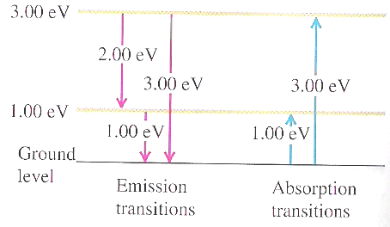which, if any, are in the visible range. (413 nm, 620 nm, 1240 nm)

E = hc / λ

3

1

λ1 = (4.14x10-15)(3x108) / 2eV = 6.21x10-9 m = 621 nm

λ2 = (4.14x10-15)(3x108) / 1eV =1242x10-9 m = 1242 nm

λ3 = (4.14x10-15)(3x108) / 3eV = 414x10-9 m = 414 nm

-1.0 eV

-1.00 eV

-3.0 eV

-3.00 eV

-4.0 eV

2

-4.00 eV

1. The diagram below shows the lowest four discrete levels of an atom. Note: Energy levels are not drawn to scale.

*n* = 4

Unknown: Calculated in part c.

*n* = 3

-6.04 eV

*n* = 2

-13.6 eV

*n* = 1

-54.4 eV

* 1. Determine the frequency of the lowest energy photon that could ionize the atom, initially in its ground state. (1.31 x 1016 Hz)

E = hf

54.4 = (4.14x10-15 ) f

54.4 = f

4.14x10-15

1.31x1016 Hz = f

* 1. What frequency photon would be given off by an electron if it fell from the n = 3 to n = 1 state?

54.4 – 6.04 = 48.36 Ev

E = hf

48.6 = (4.14x10-15) f

48.6 = f

4.14x10-15

1.17x1016 Hz = f

An electron in the n = 4 state makes a transition to the n = 2 state, emitting a photon of wavelength 121.9 x 10-9 m.

* 1. Calculate the energy level of the n = 4 state. (-3.4 eV)

E= hf ΔE = n2 – n4

E = hc / λ 10.08 = 13.6 – n4

E = (4.14x10-15)(3x108) n4 = 13.6 – 10.18

121.9x10-9 n4 = 3.42 eV

E = 10.18 eV

**Nuclear Physics and Radioactivity**

**Structure and Properties of the Nucleus**

Review of the Nucleus

* Two types of particles in the nucleus –**NEUTRONS** and **PROTONS**.
  + proton – positive charge of +q, mass (mp) = 1.67262 x 10-27 kg
  + neutron – electrically neutral, mass almost identical to proton, mn = 1.67493 x 10-27 kg
* **NUCLEONS** – refers to particles of the nucleus (protons AND neutrons)
* Atomic Number (Z) – the number of **PROTONS**
* Atomic Mass Number (A) – the total number of protons and neutrons
* An element can be denoted by using the following symbols:

This represents an isotope of Uranium that has 92 protons and 238 nucleons (146 neutrons). Note that the **MASS** number goes on top and the **ATOMIC** number goes on the bottom.

238

A

Z X 92 U

|  |  |
| --- | --- |
| **Particle** | **Mass (kg)** |
| proton | 1.67262 x 10-27 |
| neutron | 1.67493 x 10-27 |
| electron | 9.11 x 10-31 |

**Mass of Elemental Particles**

**Isotopes**

Isotope – nuclei that contain the same number of protons, but different numbers of **NEUTRONS**. Isotopes are generally written as “element name – mass number”, i.e.

carbon - 12 or carbon - 13

(6 p+, 6 n0) (6 p+, 7 n0)

13

12\_\_

CC

6

6

* + the # of **PROTONS** defines the element, but there can be multiple isotopes with a different number of neutrons.
  + even the simplest element, hydrogen, has isotopes:

1

* + - H, **PROTIUM**

2

1

* + - H, **DEUTERIUM**

3

1

* + - H, **TRITIUM**

1

**Einstein’s Equation - E = mc2**

You may have heard of Einstein’s equation many times, but did you ever stop to think about what is means? The equation, which relates energy, mass and speed of light **( 3x108 m/s ),** is a statement of a powerful concept: That **MASS** can be converted into pure **ENERGY** and visa-versa. This mass energy equivalence is at the heart of **NUCLEAR PHYSICS** and its applications, such as **NUCLEAR POWER.** The following equation **E = mc2** describes how much **MASS** is associated with a given amount of **ENERGY**. It also describes how much **ENERGY** it takes to create a given amount of **MASS.**

**Sample**

1kg of matter moving at the speed of light.

E = mc2

E = (1 kg) ( 3x108 )2 = 9 x 1016 J

**Binding Energy**

* FACT - the total mass of a **STABLE** nucleus is always **LESS** than the sum of the masses of its constituents (protons and neutrons).

4

Example: Consider the neutral helium atom, 2 He

mass of constituents =

2 proton 2 neutrons 2 electrons

(2 x 1.67262) + (2 x 1.67493) + (2 x 9.11x10-31) = 6.698x10-27 kg

But the mass of helium – 4 is actually 6.6443x10-27 kg, which is

**5.37 X 10-29** kg less than the masses of its constituents. Where did the

mass go?

* This difference in mass (Δm) is called the **MASS DEFECT**
* The “lost mass” has gone into energy of another kind and is called the **total BINDING ENERGY**, where

EB = Δmc2

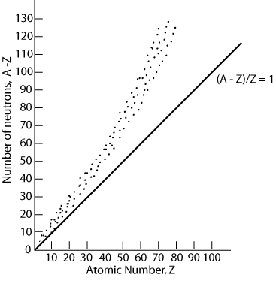The binding energy is measured in joules and represents the

amount of energy that must be put into a stable nucleus in order to break it apart into its protons and neutrons.

**Nuclear Forces**

* STRONG nuclear force – an attractive force that acts between

protons and neutrons

* Protons attract each other via the nuclear force while they repel

each other via the electric force. Since nucleus holds together,

the nuclear force is **STRONGER** than the electric force (and stronger than the **GRAVITATIONAL** force).

* Nuclear force only acts over very short distances (< 10-15 m).
* If the nucleus contains too many (or too few) neutrons

relative to the number of protons, the binding of the nucleus

is reduced and it is unstable. Nucleus stability is affected by neutron-to-proton ratio:

* + elements #1 to 20, very stable nuclei, 1 : 1 ratio of

neutrons to protons

* + elements #21 to 82, marginally stable, 1.5 : 1 ratio of

neutrons to protons

* + all nuclei with more than 82 protons (Z > 82) are

unstable and **RADIOACTIVE**

* + Note: elements with Z > 92 do not occur naturally
* When a nucleus is unstable, it “comes apart” and the result is **RADIOACTIVE DECAY**

Summary of Nuclear Properties:

|  |  |
| --- | --- |
| Stable Nucleus | Unstable Nucleus |
| Mnucleus < Mparts | Mnucleus > Mparts |
| Nuclear Force > Electrostatic Force | Nuclear Force < Electrostatic Force |
| Not Radioactive, Do Not Decay | Radioactive, Will Decay |

**Radioactivity, α-, β-, and γ- Decay**

**Radioactivity**

* Becquerel (1896) discovered that a certain mineral (which happen to contain uranium) would darken a photographic plate. Some new kind of radiation was emitted and this came to be known as radioactivity
* Marie and Pierre Curie isolated polonium and radium, highly radioactive elements
* Further work by Rutherford and others classified the rays emitted into 3 different types (alpha – α, beta – β, and gamma – γ)

**Types of Radiation**

|  |  |  |  |
| --- | --- | --- | --- |
| Property | Alpha (α) | Beta (β) | Gamma (γ) |
| Composition | HELIUM NUCLEUS | FAST MOVING e- | HIGH ENERGY EM RADIATION |
| Symbol | $\frac{4}{2}$ He | $\frac{0}{-1}$ e or e- | or $γ$ |
| Charge | +2 | -1 | 0 |
| Penetrating power | Low  (.05 mm body tissue) | Moderate  (4 mm body tissue) | Very High  (penetrates easily) |
| Shielding | paper, clothing  131  131 | metal foil | lead, concrete |

**Nuclear Reactions, Fission, and Fusion**

**Nuclear Reactions**

* The transformation of one element into another is called a **TRANSMUTATION**. This occurs by means of a nuclear reaction.
* A nuclear reaction occurs when a given nucleus is struck by another nucleus, or by a simpler particle such as a neutron or γ ray.
* Both electric **CHARGE** and the **MASS** number are conserved in nuclear reactions.
* **ENERGY** (and momentum) is also conserved in nuclear reactions.
  + If mreactants > mproducts, this decrease in mass appears as kinetic energy of the outgoing particles.
  + If mreactants < mproducts, the reaction requires energy. The reaction will NOT occur unless the bombarding particle has sufficient kinetic energy.

**Fission (DIVISION)**

* 1938/1939 – German scientists observed that the uranium nucleus, after absorbing a neutron, split into two smaller nuclei, accompanied by a tremendous release of energy.
* The two fission fragments more often split 40/60 rather than precisely half and half.
* 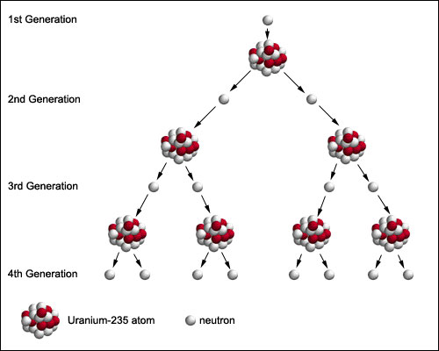Fission reaction for uranium - 235:

92

141

235

n + 92 U 56 Ba + 36 Kr + 3n

* A tremendous amount of energy is released in a fission

235

reaction because the mass of 92 U is considerably greater than the total mass of the fission fragments plus neutrons. (It is unstable).

* Since neutrons are released in a fission reaction, they can be used to create a **CHAIN REACTION**.
* The enormous amount of energy available can be released on a large scale using a nuclear reactor.

**Fusion**

* Note: The mass of every STABLE nuclei is less than the mass of its constituent protons and neutrons
* When the 2 protons and 2 neutrons come together to form a STABLE helium nucleus, there is a loss of mass (mass defect). This mass loss corresponds to the release of a large amount of energy, (E = Δmc2, binding energy)
* The process of building up nuclei by bringing together individual particles or combining smaller nuclei is called nuclear fusion.
* The sun produces its energy by nuclear fusion
* Example of fusion reaction:

2

3

p + 1 H 2 He + γ

**PRACTICE DAY**

KE = hf – Ф ΔE = hf me = 9.11 x 10-31 kg

KE = ½ mv2 c = 3 x 108 m/s v = fλ

h = 6.63 x 10-34 Js

1. An electron falls from an excited energy state to the ground state of a particular atom. Will it emit or absorb a photon during this transition? Would the arrows on an energy level diagram go up (toward the top of the page) or down (toward the bottom of the page)?

It will emit a photo. The arrow will be drawn towards the bottom of the page.

2. An electron orbiting a nucleus makes a jump from an energy level at -7 eV up to an energy level at -3 eV.

a. By how much did the energy of the electron change?

ΔE = Ef – Ei

-3 - –7 = 4 Ev

b. The electron was excited to this state by a collision with an incident photon. How much energy did the photon have to have before it was able to cause this transition?

If 4 eV are given off, then it will take 4 eV to move it back to its original place.

c. What frequency and wavelength did this incoming photon have?

E= hf c = f λ

4eV = (4.14x10-15)f c / f = λ

4 / 4.14x10-15 = f 3 x108 / 9.66x1014 = λ

9.66x1014 Hz 3.11x10-9 m

3. The diagram below shows an energy level diagram for a simple atom.

A

C

B

n = 4 (-2.9 eV)

n = 3 (-3.5 eV)

n = 2 (-4.4 eV)

n = 1 (-6.5 eV)

n = 1 (-6.5 eV)

a. If a photon with a wavelength of 413 nm was incident upon an electron in the ground state, to what level could it excite the electron? Draw this transition above.

E = hc/λ It can move up 3 eV from n1 to n3

E = (4.14x10-15)(3x108) = 3 eV

413x10-9

b. The electron will not stay at this excited state for long, perhaps only fractions of a second. Draw ***ALL*** of the possible transitions of the electron as it eventually returns to the ground state and emits photons.

Possible moves : n3 to n2 = .9 eV then n2 to n1 = 2.1 eV Total of 3 eV

Or it can move from n3 to n1 = 3 eV

c. For part "b" you should have drawn three transitions. Calculate the wavelength of the three possible photons associated with those transitions.

E = hc/λ

Λ = hc / E

Λ = (4.14x10-15)(3x108) (4.14x10-15)(3x108) (4.14x10-15)(3x108)

.9 eV 2.1 eV 3 eV

= 1380x10-9 m or 1380 nm = 591x10-9 or 590 nm = 414x10-9 or 414 nm

d. How much energy would a photon need to ionize this atom?

E = 6.5 eV ionize mean get it out of the ground state (n1)

e. For part "d", what wavelength would this photon have?

λ = hc / E (4.14x10-15)(3x108) = 191x10-9 m or 191 nm

6.5 eV

4. A scientist tells you that a newly discovered atom has energy states at the following values:

-7.1 eV, -4.3 eV, -1.9 eV

a. He also tells you that the -7.1 eV is the ground state of the atom. Draw an energy level diagram of this atom below:

-1.9 eV

-4.3 eV

-7.1 eV

b. An electron is excited to the -4.3 eV energy state, and then falls back down to the ground level. How much energy is given off by the electron in the form of a photon as it falls back down?

* + - 4.3 + +7.1 = 2.8

c. What is the frequency of the emitted photon from part "b"?

**E = hf**

**2.8 = (4.14x10-15) f**

* 1. **/ 4.14x10-15  = f**

**6.76x1014 Hz = f**